MICROBIOLOGY USER MANUAL

1. INTRODUCTION
   1. SCOPE AND PURPOSE.

This module allows the for PT testing on microbiology on different labs across the country

In the microbiology modules, it contains majorly 2 parts,

1. Administration sub-module.

The admin side where the admin user gets to create the test samples ,rounds, grading etc…

1. the lab/participant sub-module.

Here the participating lab gets to view the received samples and enter the results and give back their results.

* 1. PROCESS OVERVIEW.

Firstly, the PT admin get to log into the system and will then create the samples,the samples are then packages into packages,the packages are then added to shipments which he/she should have created prior.

On addition to that the user creates a round of testing,once the round has been created he/she add shipments and participating labs to the rounds.

Once everything has been correctly set up,the round can then been started.

Its important to note that every step is necessary otherwise no round can be strartd if an of the step is skipped

Basic description of the steps

* Log in.
* Add labs.
* Add lab user who can log in.
* Map users to labs
* Create samples
* Create panels.
* Add samples to panels.
* Create shipments
* Add panels to shipments
* Create rounds
* Add shipments to rounds
* Add labs to rounds
* Start round
* Wait for the results to be evaluated

At the lab level.

* User logs in.
* Receives the sent shipments
* Issues sample to user(which can be himself/herself)
* The takes the test/fill a fomr with his/her foundings
* The submits
* After the results have been evaluated, the user can be able to view the results.
  1. Common Icons and what they mean
*  Print Barcode
*  Lock/deactivate item
*  Delete item
*  Edit Items
* Show detailed and wider view
*  Show extra information/add instructions
*  refresh or fetch data for the current page
*  Add items to the current time
* Export to excel
*  Print pdf

1. PROCESS WORKFLOW
   1. Micro Sample Preparations
      1. Logging in

Before any user can access th system,he/she must login in,as shown in the image below.

Please enter the correct email and password or else you wont be able to login.

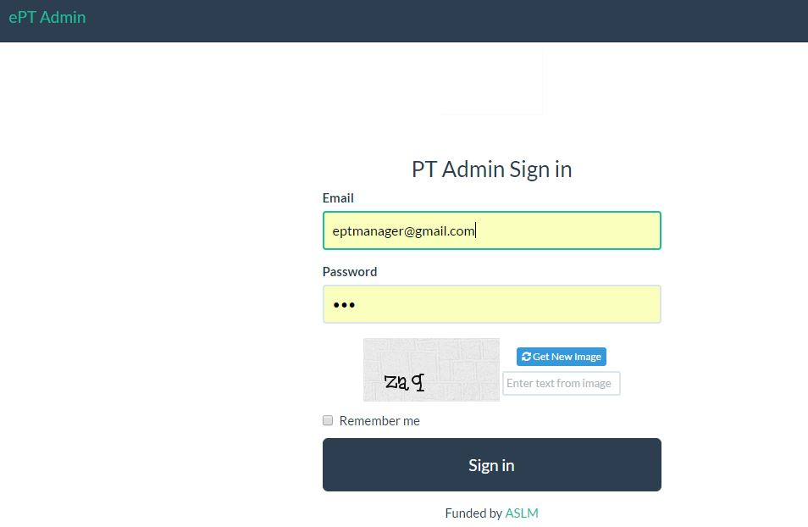

Figure 1

* + 1. System access.

On successful log in ,menus will appear on the top and will alnd on the the below homepage.

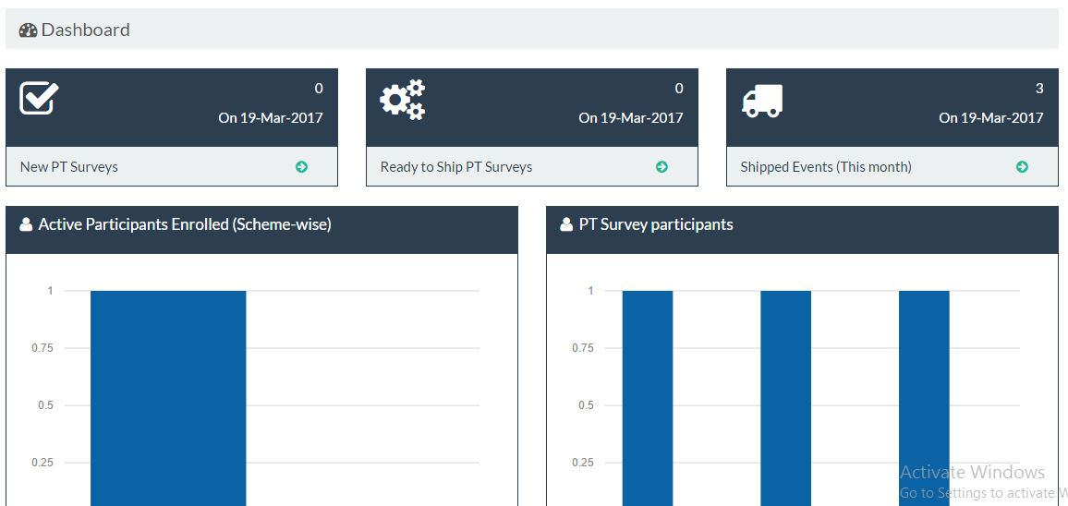

Figure 2

* + 1. Add PT Managers.

On the configure menu dropdown, click on Admin manager.

You will see the below page, click on the circled button to add a new Admin Manager

The available ones also appear here.To edit an available pt manager,click on the edit button on every row.

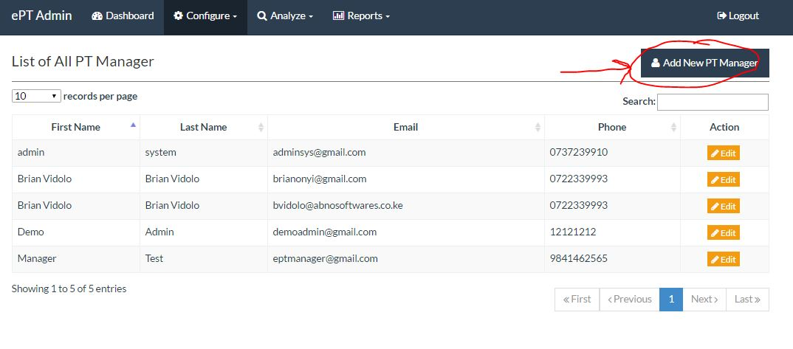

Figure 3

The below form appear, please fill all the fields marked us mandatory.

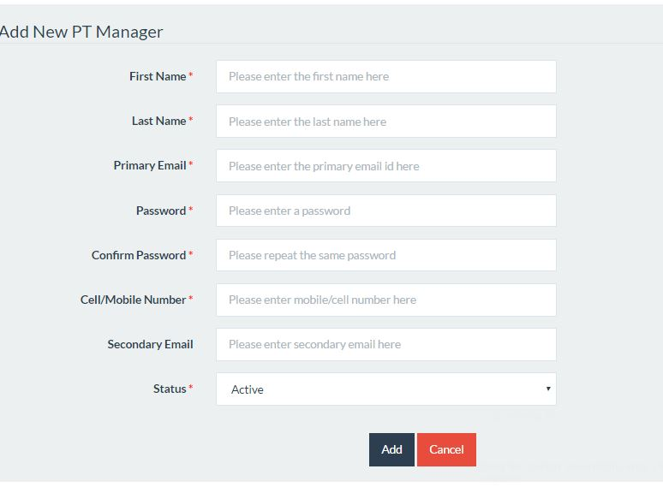

Figure 4

* + 1. Labs.

From the configure menu, click on the micro labs.

To add a new lab click on the circled button.This page also shows all available labs.To edit an existing click on the edit button.

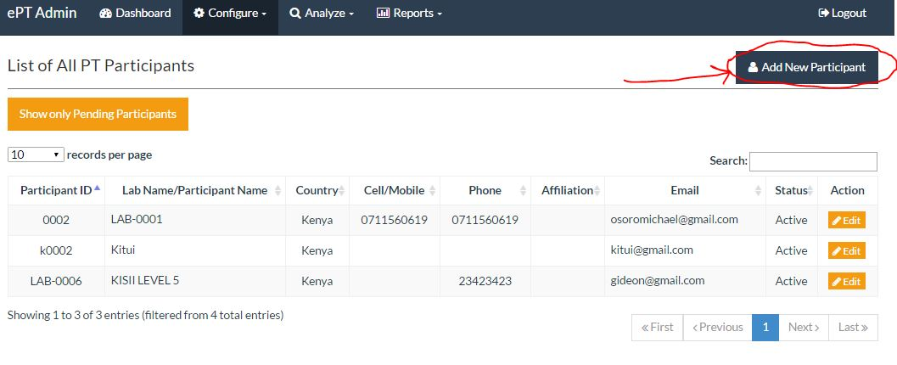

Figure 5

* + 1. Users

From the configure down drop , click on users, figure 6 below appears

* + - 1. View/edit Laboratory Managers

To edit on a user click the edit button on each row

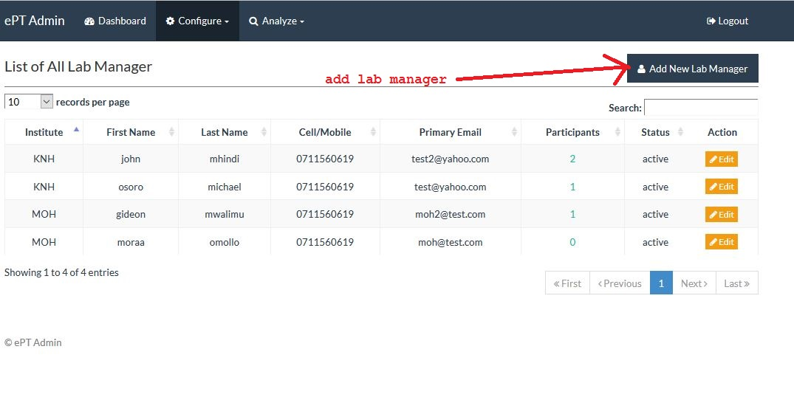

Figure 6

* + - 1. Add new Laboratory Manager

On view part once the add new lab manager button is clicked, the below form appears. Please fill the fields marked with red

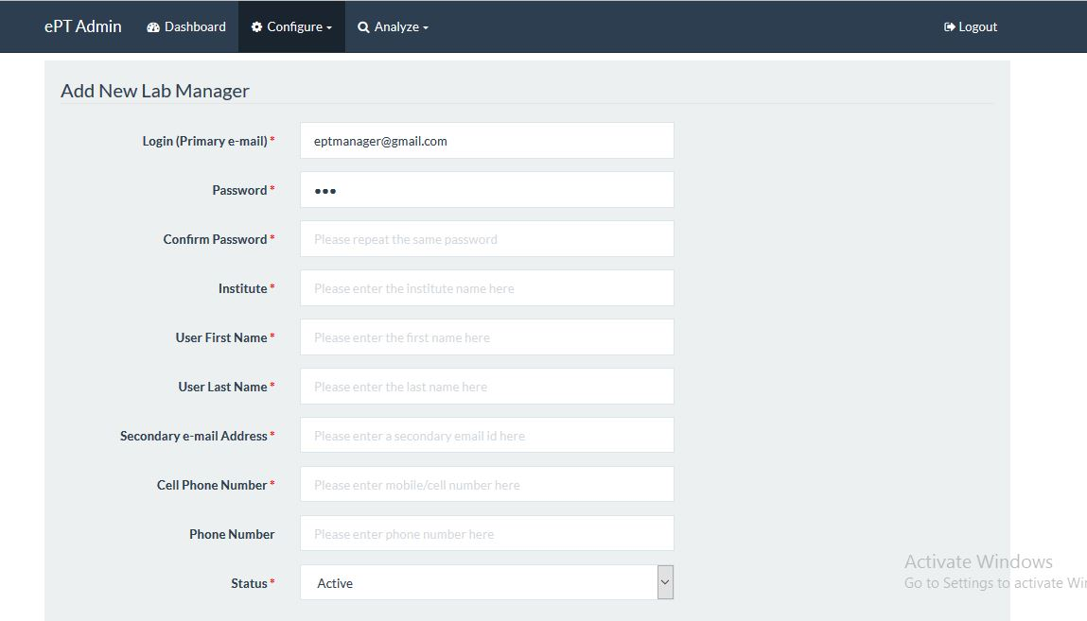

Figure 7

* + 1. Lab and user mapping.

From the configure drop down,click on lab & user mapping,the below page occurs.

To map a user to a lab,choose a lab on the left,the current users not on that lab appear.on

The right users already enrolled on that lab also appear,click on a user to mode or remove

User from the lab i.e click user on the left adds the user to a lb,click on the user on the left

Removes the user from the lab.

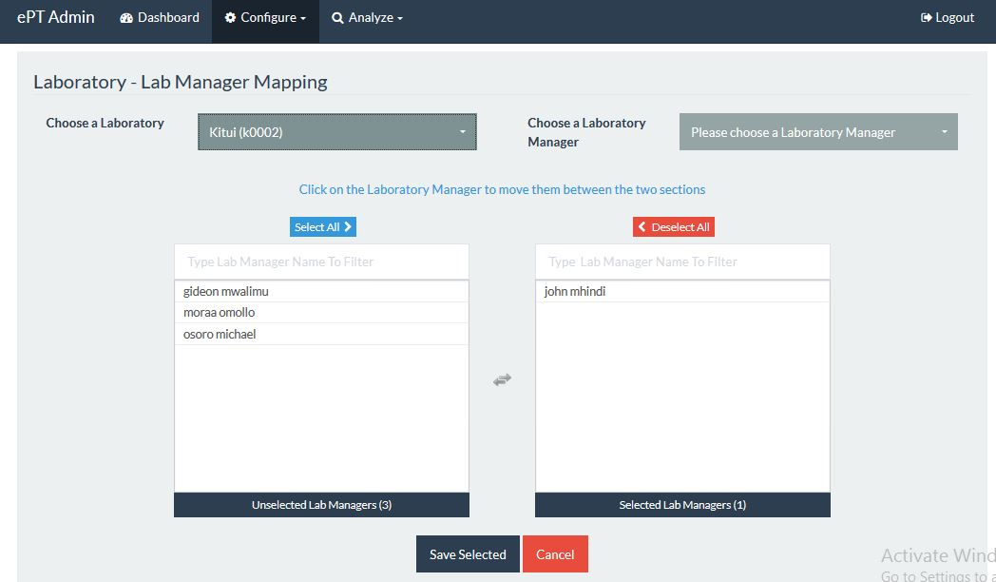

Figure 8

* + 1. Samples.

From the main menu, click on configure then click on micro-biology. The page represented by the figure 9 appears.

Figure 9 demonstrates and shows all the button on it and what they do. Its important to note that ,you have to click  to load/refresh data.

* + - 1. Edit/delete and view samples

To edit or delete please click on the edit and delete buttons respectively.

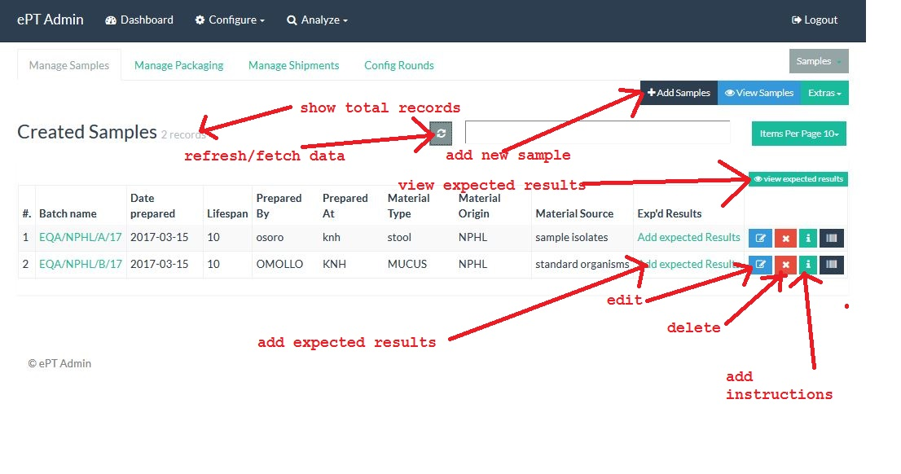

Figure 9

* + - 1. Add Samples

Once the add samples button on the top is click figure 10 appears, please fill all the fields then click save , you will be redirected to the main/view samples page.

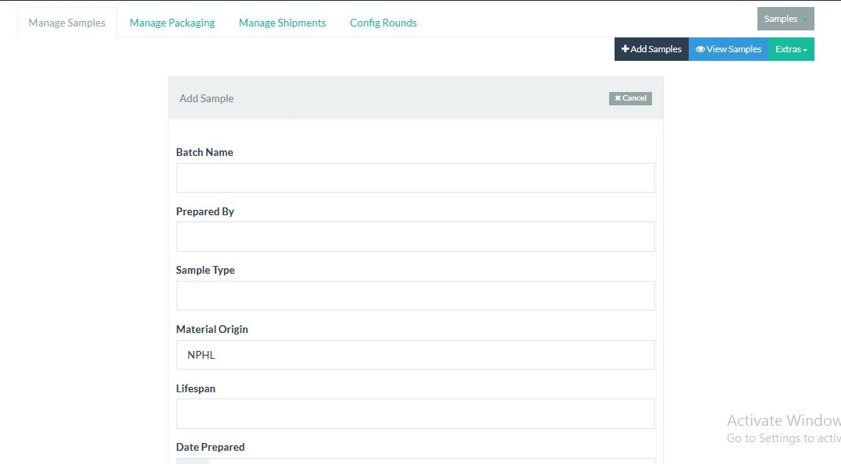

Figure 10

* + - 1. Add/edit/view sample instructions

Click on the add instructions as labelled on figure 9,below form appears,by default its filled,please edit the form where necessary and click save to save the form

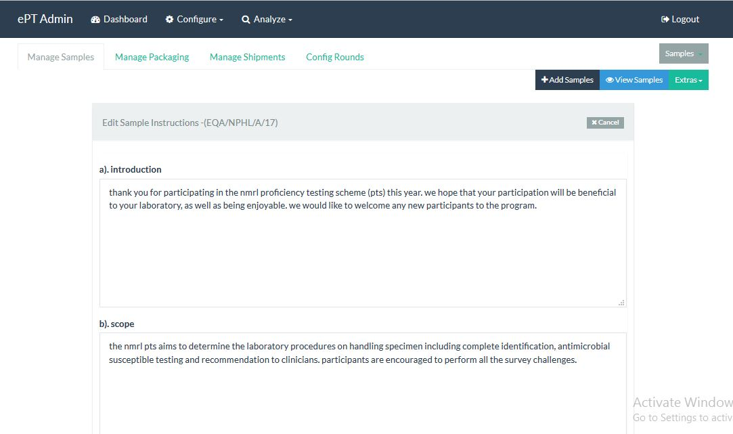

Figure 11

* + - 1. Add/edit expected results data/view

Click on the add expected results link,below fomr appears ,fill the fields and click save,this are the results that will be used to evaluate the labs

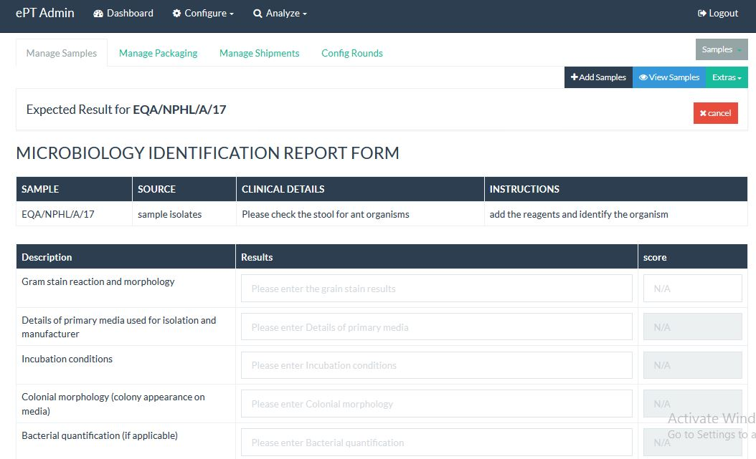

Figure 12

* + - 1. Add sample grading

On the Extras menu click on grades ,the add grade appears

* + - * 1. Add grade

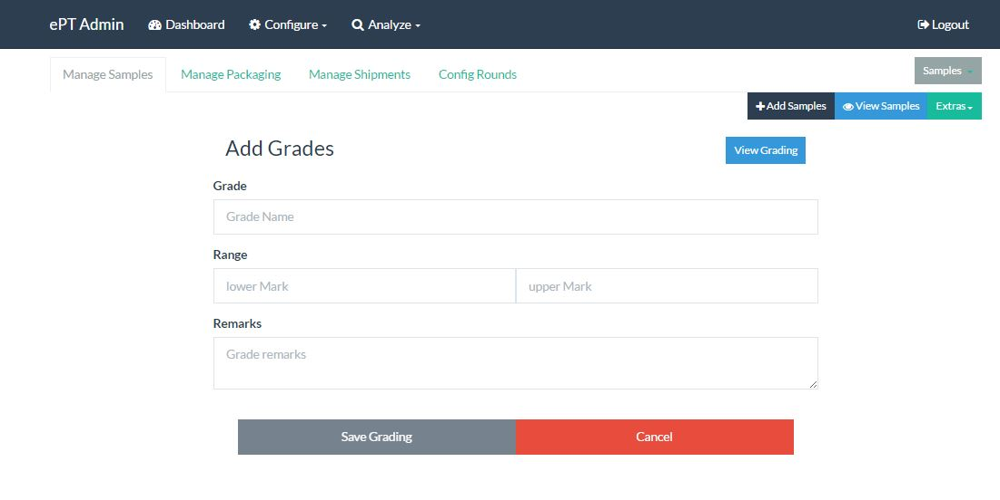

Figure 13

* + - * 1. View Grades

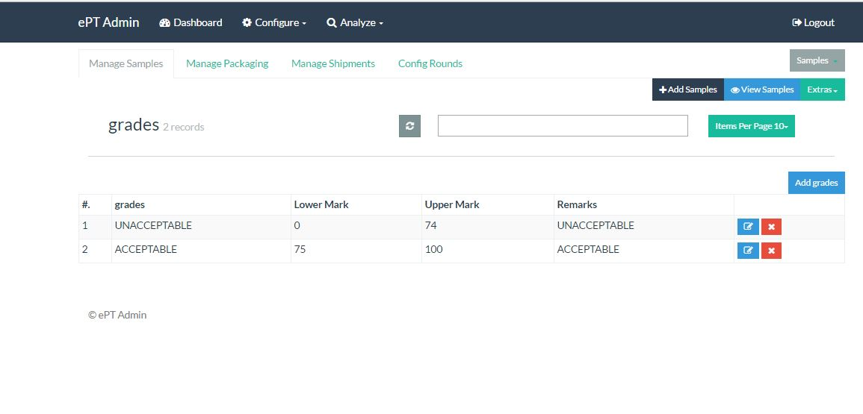

Figure 14

* + - 1. Add test reagents
         1. Add Test reagents

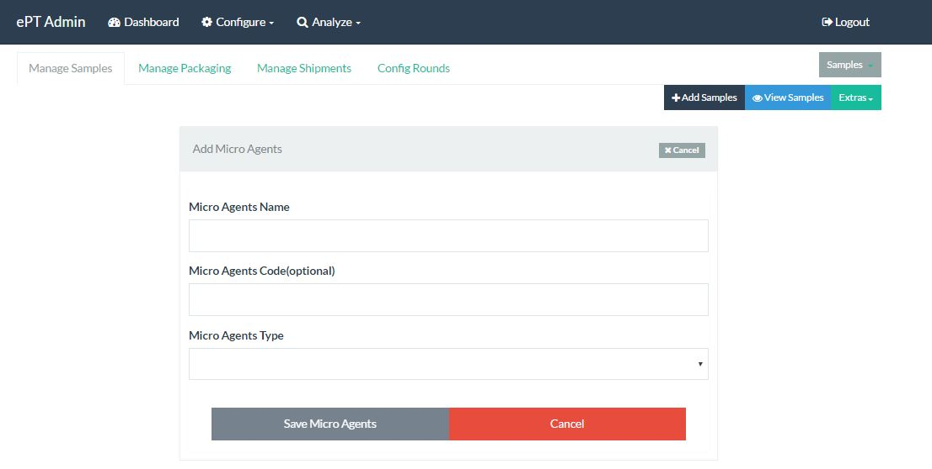

Figure 15

* + - * 1. View Test reagents

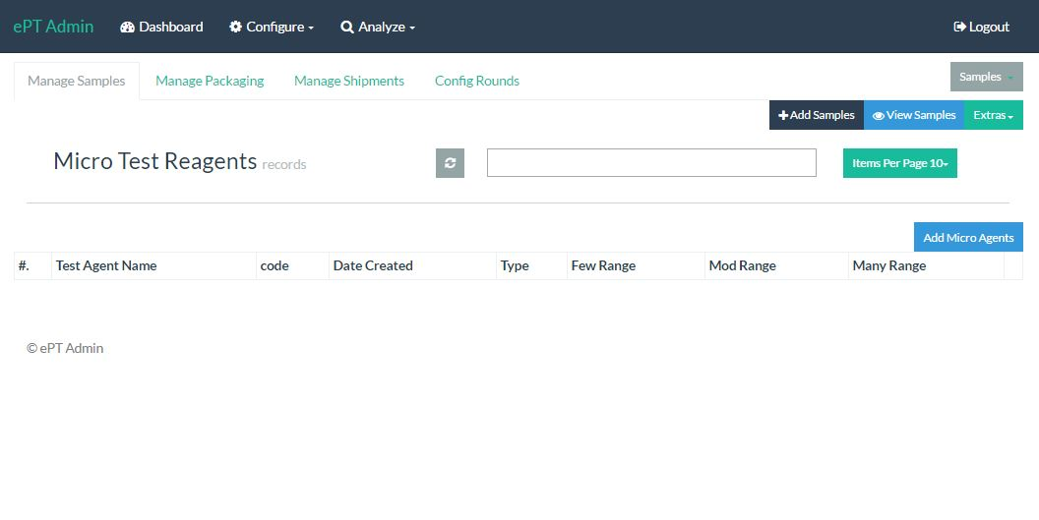

Figure 16

* + - 1. Add sample types
         1. Add Sample Type

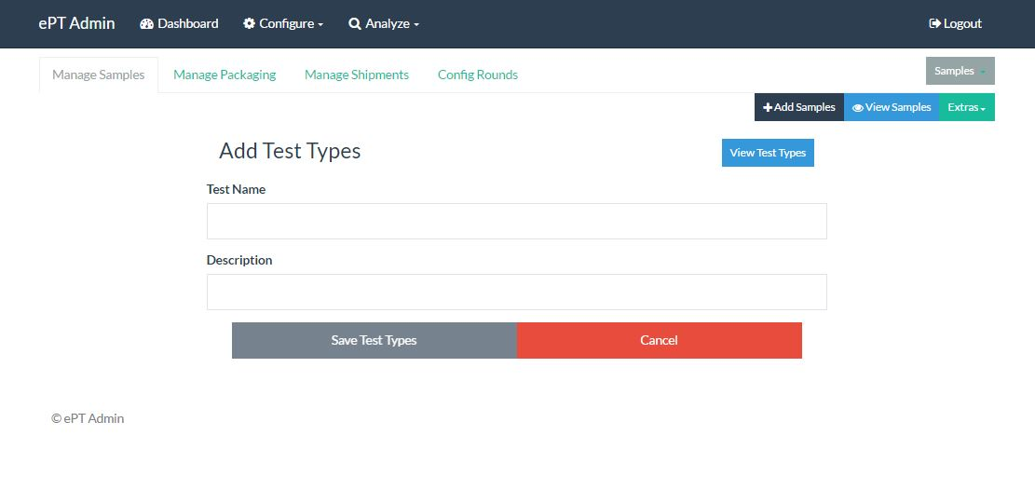

Figure 17

* + - * 1. View Sample Type

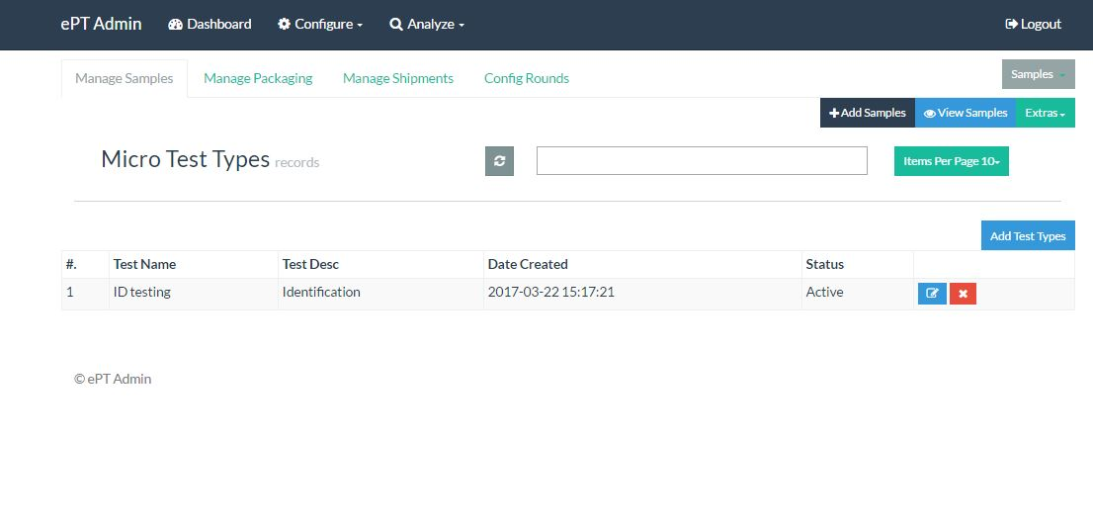

Figure 18

* + - 1. View Sample Summary.

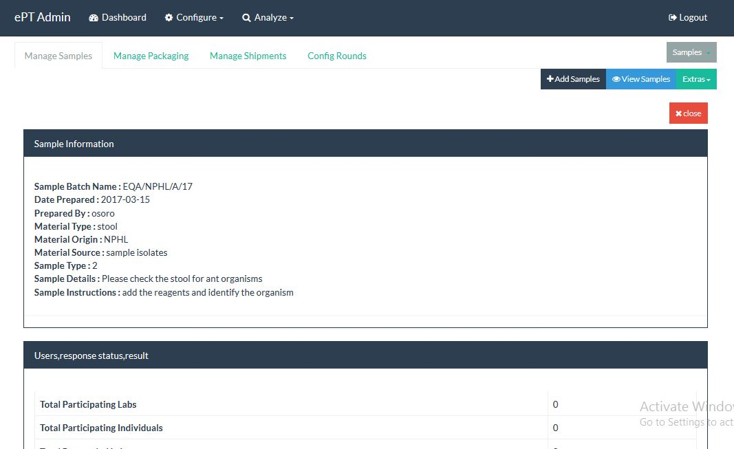

Figure 19

* + 1. Packaging
       1. Add/edit/delete and view packages

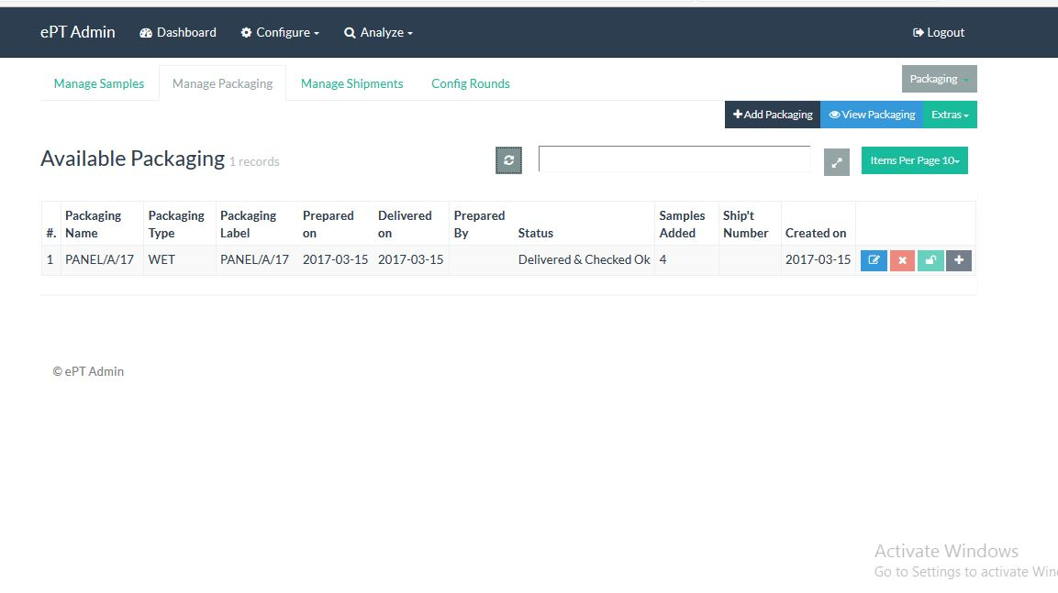

Figure 20

Add Package.

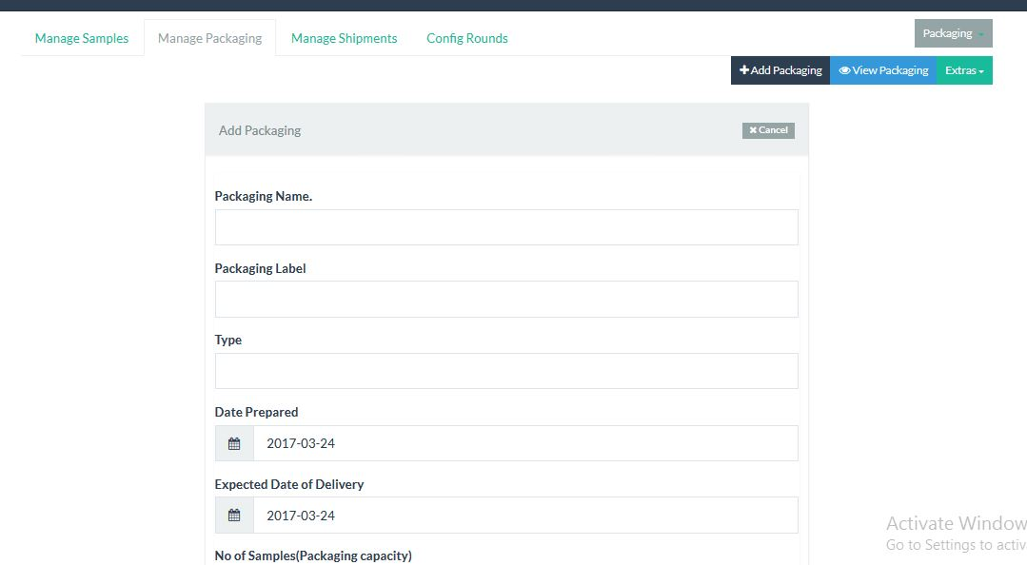

Figure 21

* + - 1. Add samples to panels to package

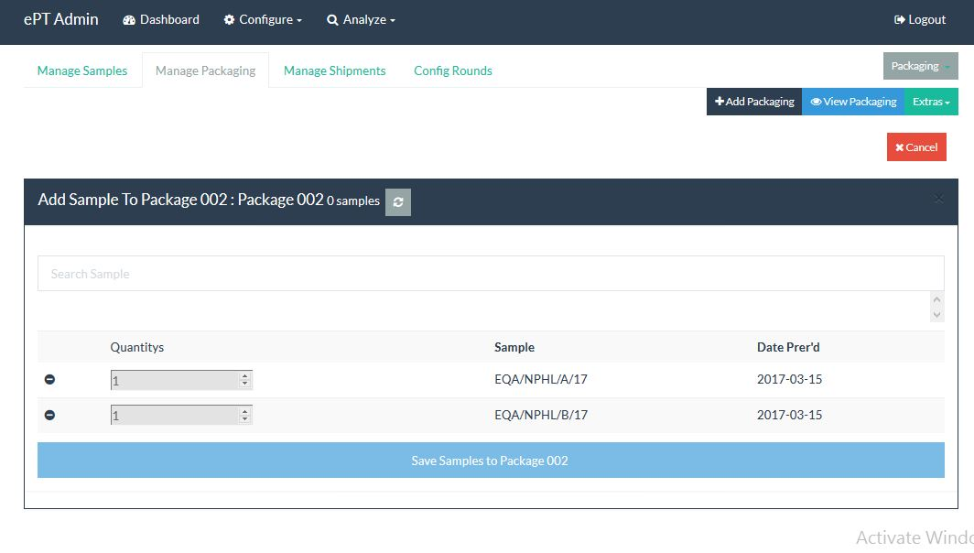

Figure 22

* + - 1. View samples in a package

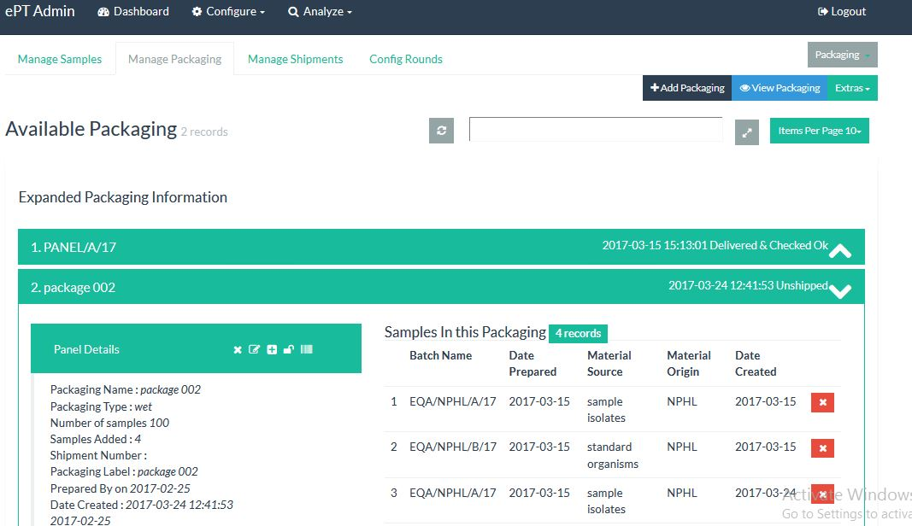

Figure 23

* + 1. Shipments
       1. Add/edit/delete and view

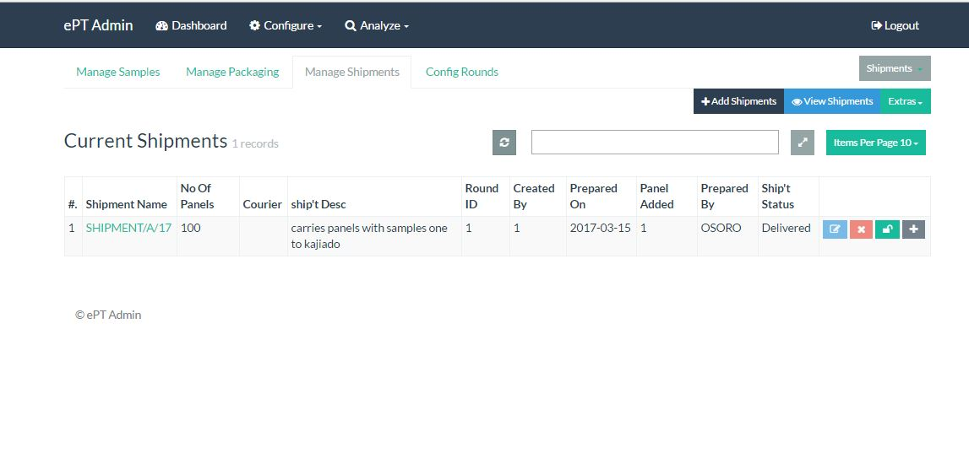

Figure 24

Add Shipment

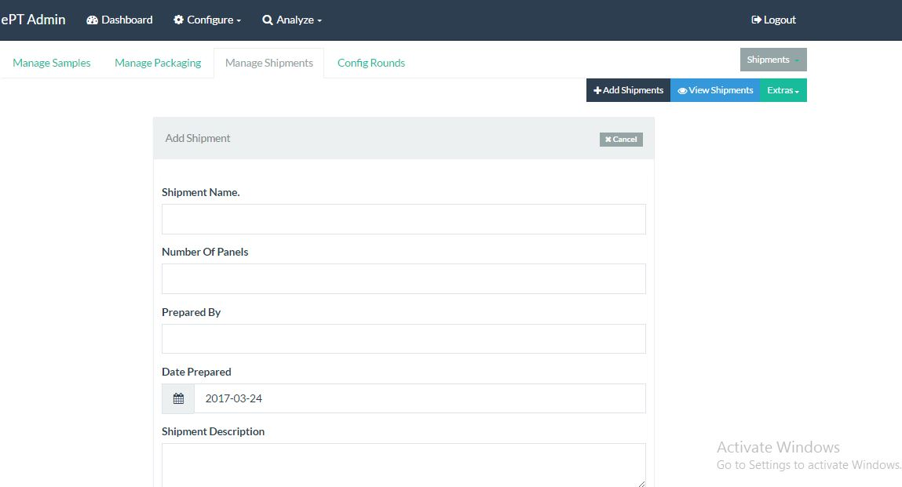

Figure 25

* + - 1. View/panels to/on shipment

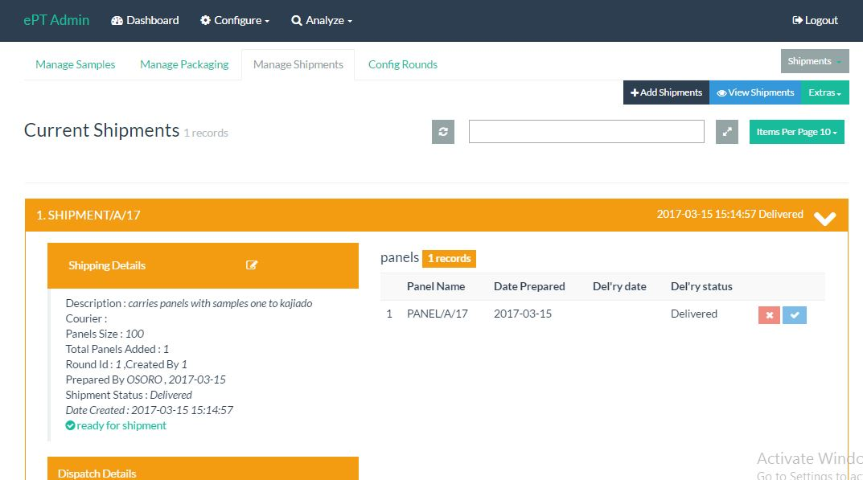

Figure 26

* + - 1. Add panels shipment

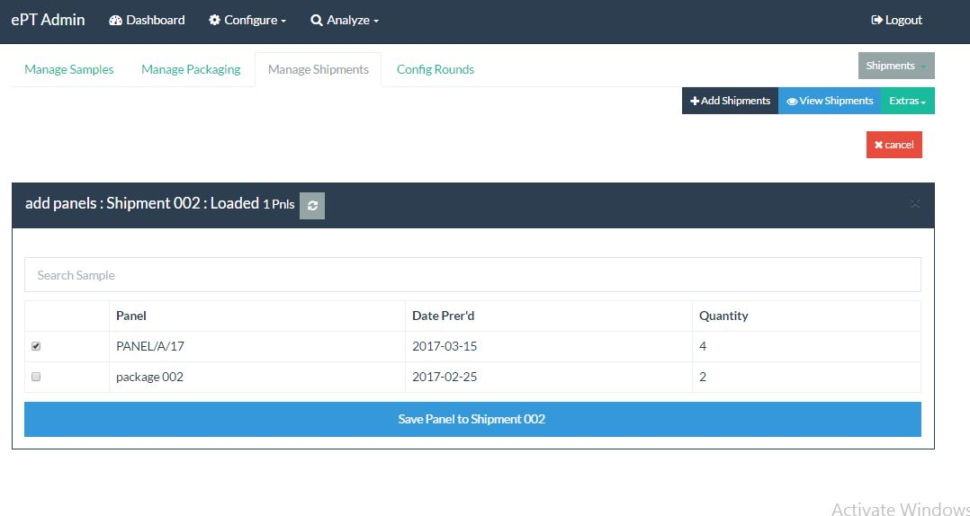

Figure 27

* + - 1. Shipment Full Information.

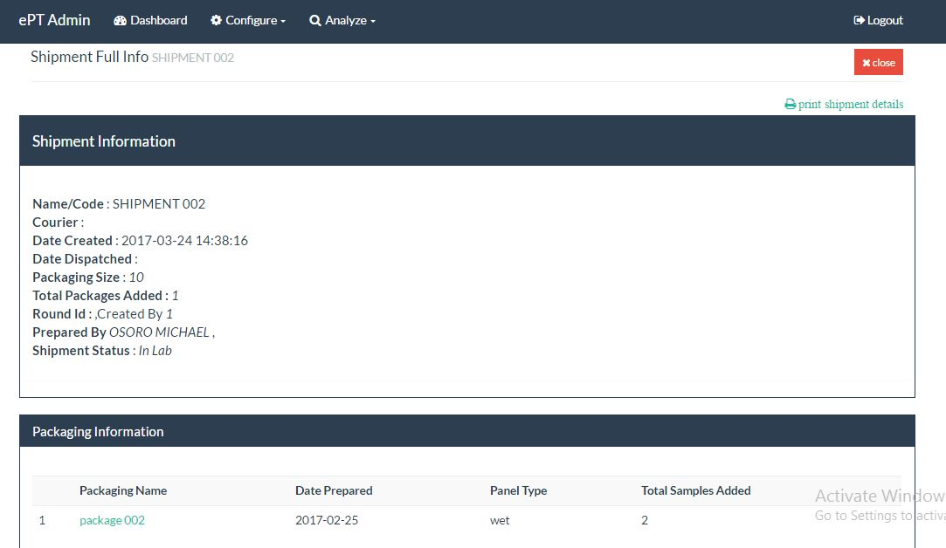

Figure 28

* + - 1. Dispatch Shipment.

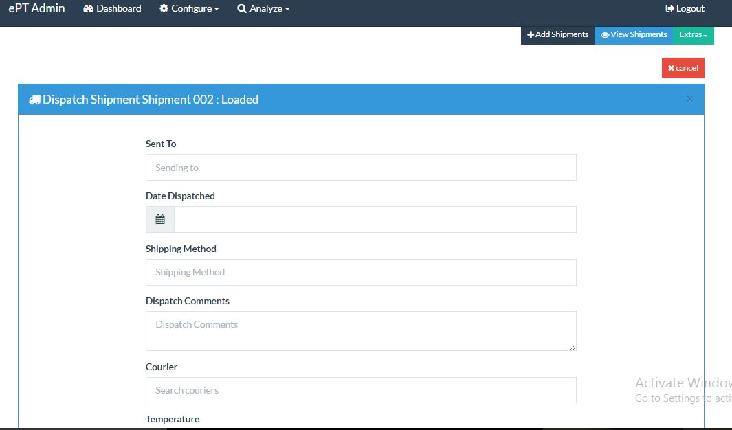

Figure 29

* + 1. Rounds
       1. Add/edit/delete and view

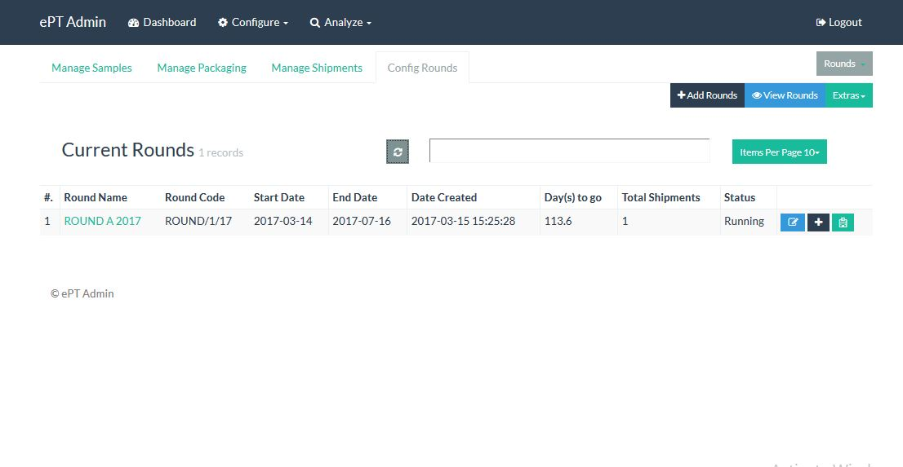

Figure 30

Add Round

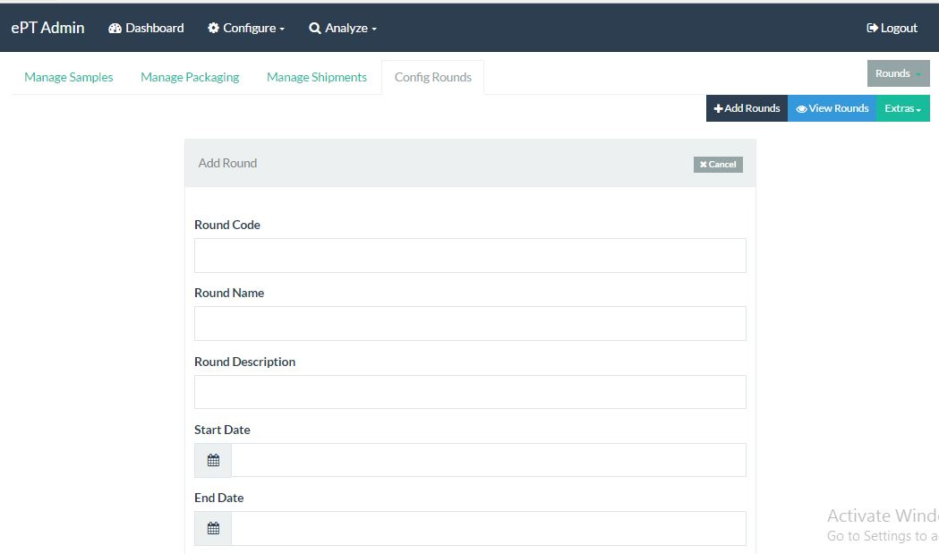

Figure 31

* + - 1. Add shipments to rounds

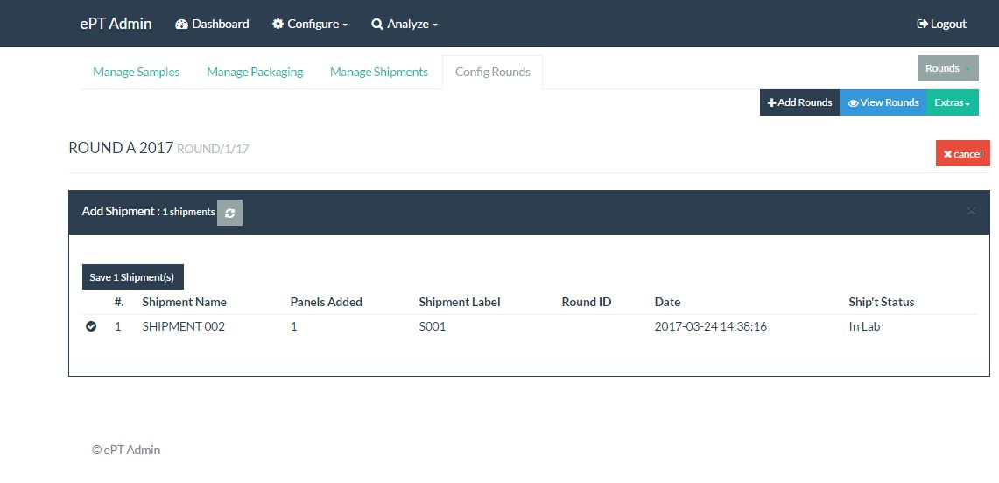

Figure 32

* + - 1. Enroll lab for the round

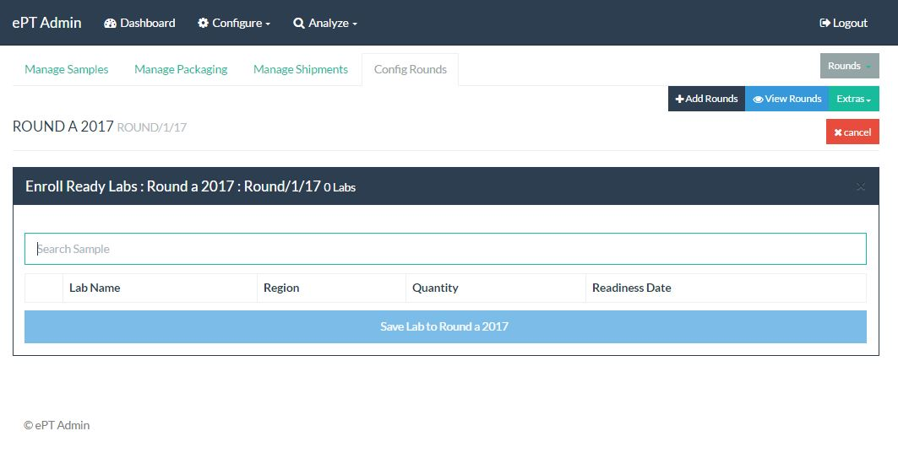

Figure 33

* + - 1. Start Round

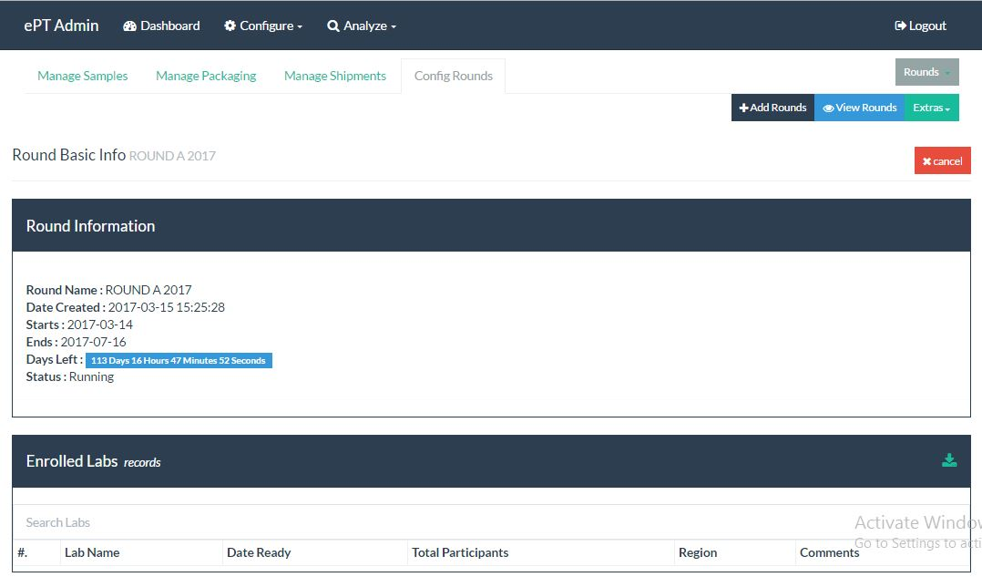

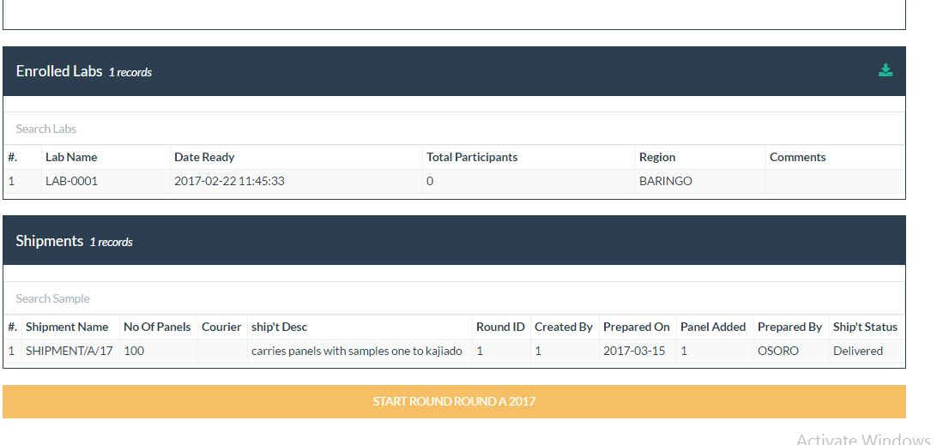

Figure 34

* + 1. Extras

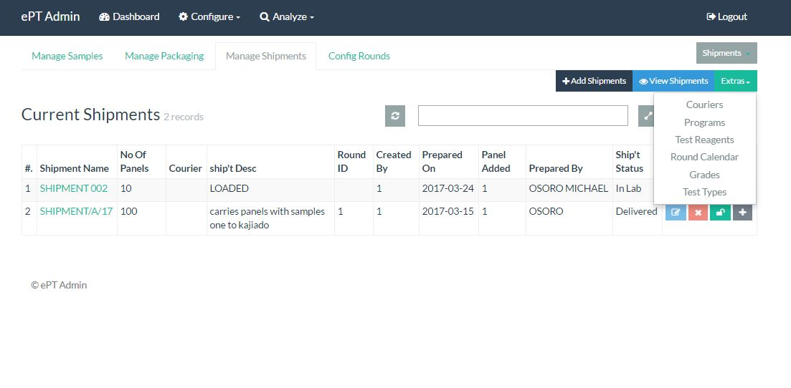

Figure 35

* + - 1. Couriers

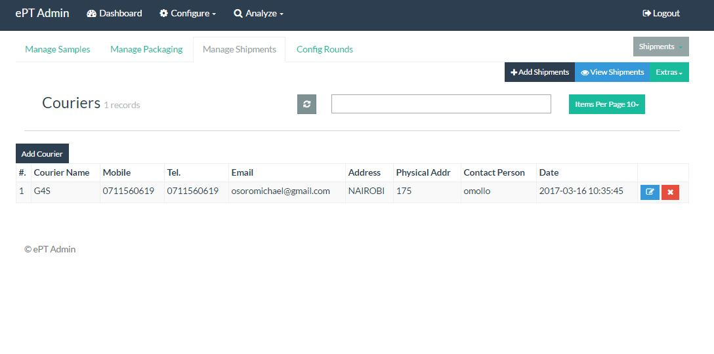

Figure 36

Add Courier.

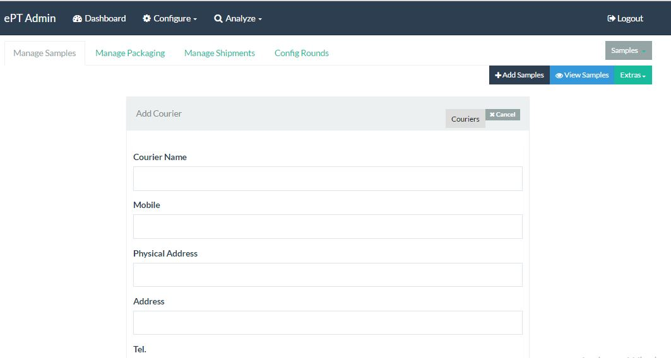

Figure 37

* + - 1. Round Calendar
  1. Micro-Reports
     1. Evaluation
        1. Round Evaluation
           1. Round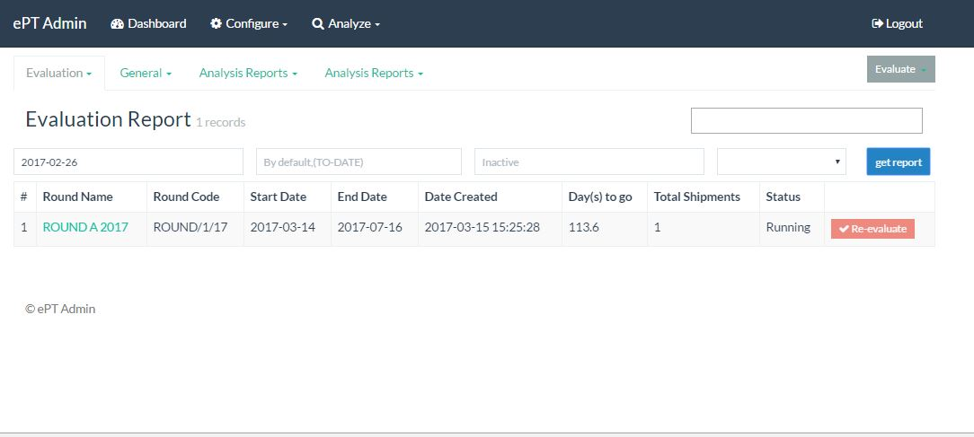

Figure 38

* + - * 1. Shipment
      1. Individual Evaluation

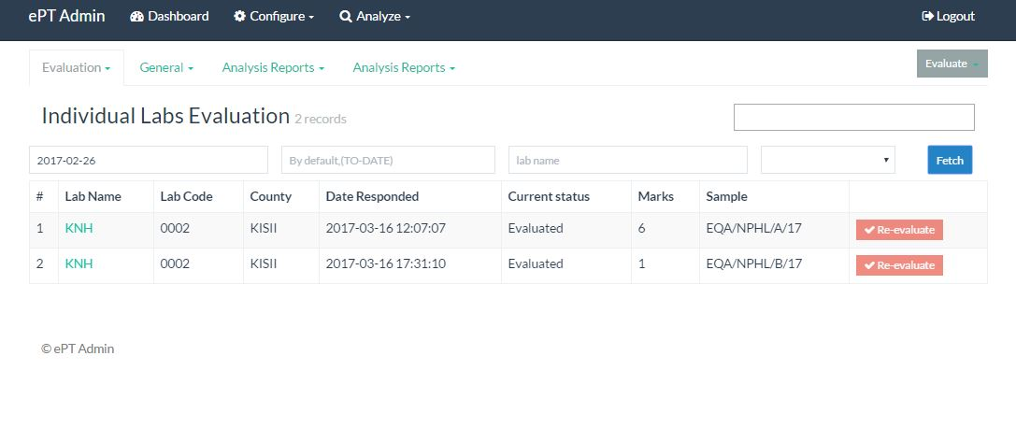

Figure 39

* + - 1. Publish

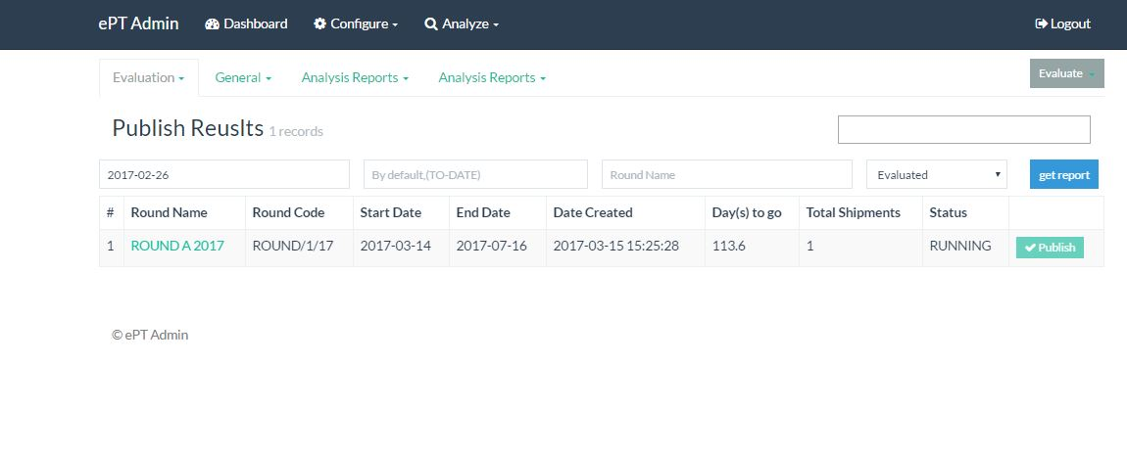

Figure 40

* + 1. General
       1. Shipment

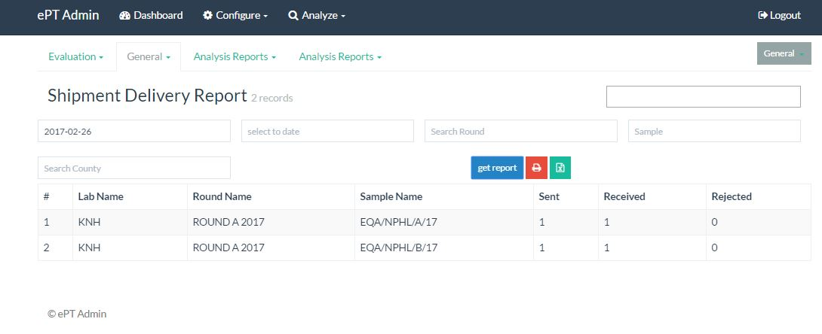

Figure 41

* + - 1. Corrective action

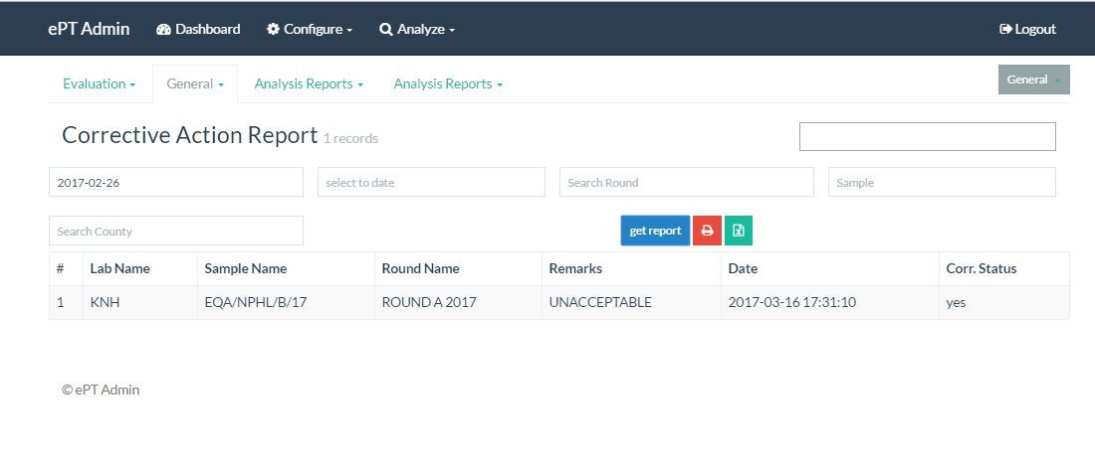

Figure 42

* + 1. Analysis
       1. Labs

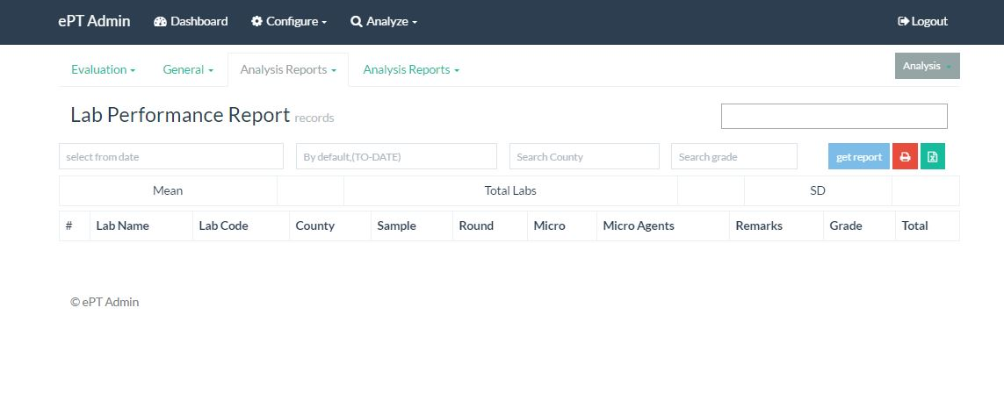

Figure 43

* + - 1. Round

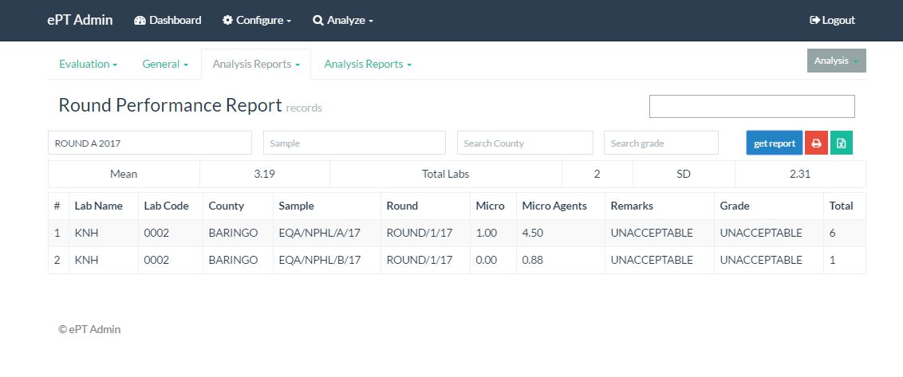

Figure 44

* + - 1. Participatory

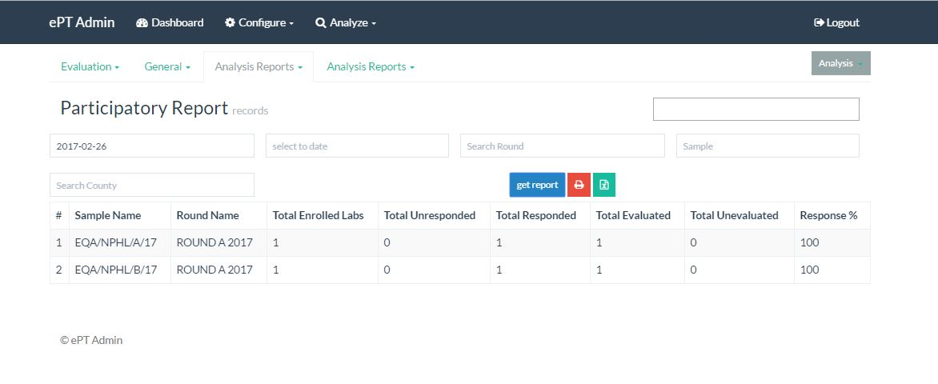

Figure 45